PAYMENT BEHAVIOUR &
DIGITAL PAYMENT INTELLIGENCE
PROJECT REPORT

Fundamentals of Machine Learning (MLE2503)
Semester 5 | Amity School of Engineering and Technology

Name: DAKSH VERMA
Enrollment Number: A501132524005

1. Abstract
This project explores whether customers can be grouped by their payment preferences and transaction behaviour. The analysis starts with transaction-level records and summarizes them into customer-level features, such as transaction frequency, average transaction value, payment-mode ratios, cashback usage and EMI usage. K-Means is compared with Agglomerative clustering. The project also compares a payment-only feature set with a wider set that includes spending and offer behaviour. The results are evaluated using the Silhouette Score and Davies–Bouldin Index, with Elbow and PCA plots used to support interpretation. The intended use is to inform payment experience and promotion planning.

2. Problem Statement and Objectives
Retailers and payment providers serve customers who use different payment methods and respond differently to offers. A single payment or promotion strategy may not suit everyone. The aim is to use unsupervised machine learning to find groups with similar behaviour, then describe those groups in business terms.
The objectives are to inspect and clean transaction data; engineer customer-level features; compare payment-only and combined feature sets; compare K-Means with hierarchical clustering; evaluate the resulting clusters; and make recommendations that follow from the measured profiles.

3. Dataset and Variables
The file synthetic_payment_transactions.csv contains 18,109 rows before cleaning and represents 1,000 customer IDs. Its columns are transaction_id, customer_id, transaction_date, payment_mode, transaction_amount, cashback_used, discount_percent, emi_used and channel. The data was generated for this assignment workflow and includes a small number of missing payment-mode values, duplicated transaction IDs and unusually large amounts so that data-cleaning steps can be demonstrated.
The customer-level dataset is produced by grouping transactions by customer_id. Each row then describes one customer’s behaviour over the observation period.

4. Exploratory Data Analysis
The initial checks show the dataset dimensions, data types, descriptive statistics, missing values and duplicate rows. Three plots summarize transaction counts by payment mode, the transaction-amount distribution and the median transaction amount for each payment mode. These checks help identify skewed amounts and data-quality issues before clustering.
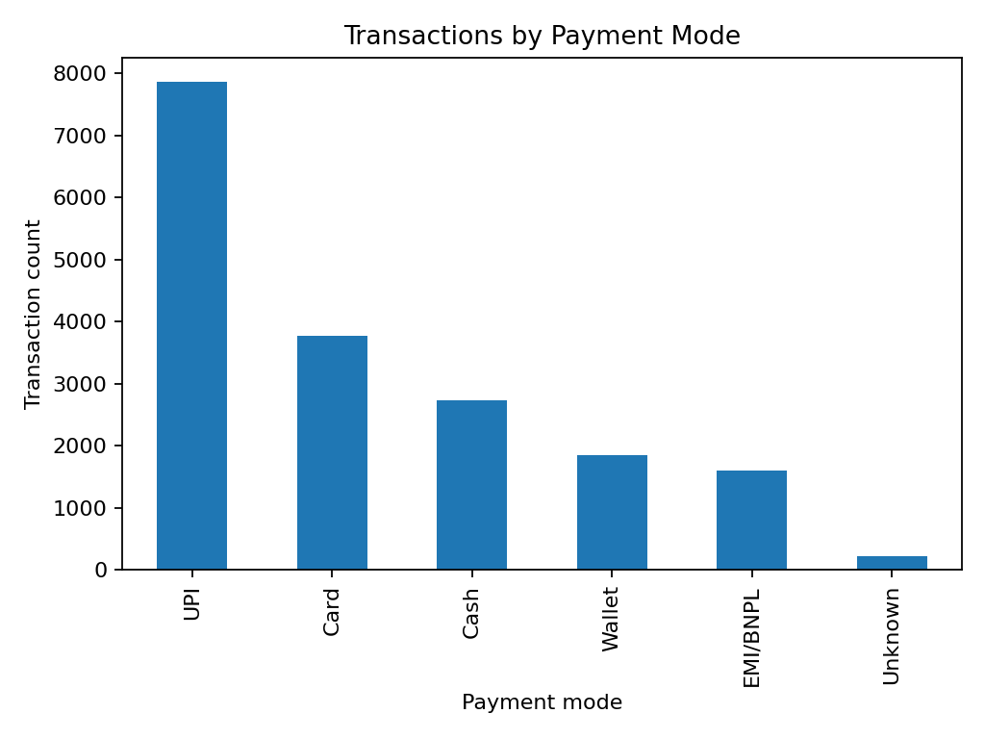
Figure 1. Number of transactions recorded for each payment mode.
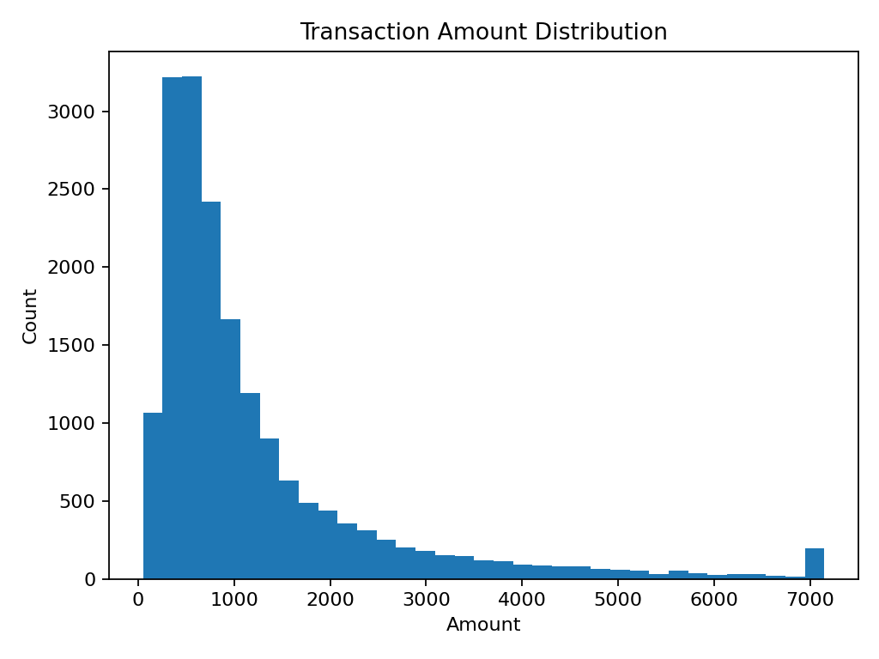
Figure 2. Transaction amount distribution after cleaning and capping.
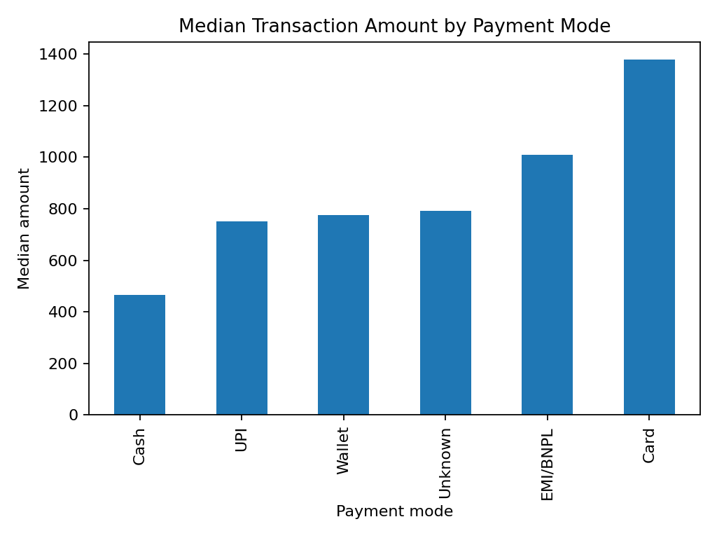
Figure 3. Median transaction amount by payment mode.

5. Data Cleaning and Feature Engineering
Rows with repeated transaction IDs are treated as duplicate transactions. Dates are converted to datetime values, missing payment modes are labelled Unknown, invalid dates and missing customer/amount records are removed, and non-positive transaction amounts are excluded. Amounts above the 99th percentile are capped for this demonstration because extreme values can dominate distance calculations. In a real dataset, unusual transactions should first be investigated to decide whether they are valid high-value purchases or data errors.

6. Methodology
The features are standardized using StandardScaler. Scaling is important because spending values can be much larger numerically than ratios. Without scaling, the spending variables could dominate the distance calculations used by K-Means.
K-Means assigns each customer to one of K groups and updates cluster centroids to reduce within-cluster squared distances. The Elbow Method compares inertia across candidate K values. The Silhouette Score evaluates how well observations fit their own clusters compared with nearby clusters; higher values are generally preferred. The Davies–Bouldin Index compares within-cluster scatter with separation between clusters; lower values are generally preferred.
Agglomerative clustering is included as a hierarchical alternative. PCA reduces the standardized feature space to two dimensions for plotting. PCA is used for visualization here; it does not assign the cluster labels.

7. Model Evaluation
Payment-only features: digital (UPI/wallet), card, cash, EMI/BNPL and Unknown-mode ratios. Combined features add transaction count, total spend, average transaction value, cashback use, discount, EMI use, channel diversity and active months. Unknown payment modes remain an explicit category.
The transaction records are summarized into customer-level features: transaction count, total spend, average and median transaction value, cashback usage, average discount, EMI usage, digital/card/cash/EMI payment ratios, Unknown payment-mode ratio, channel diversity and active months. Payment-mode ratios represent each customer’s mix of payment methods.
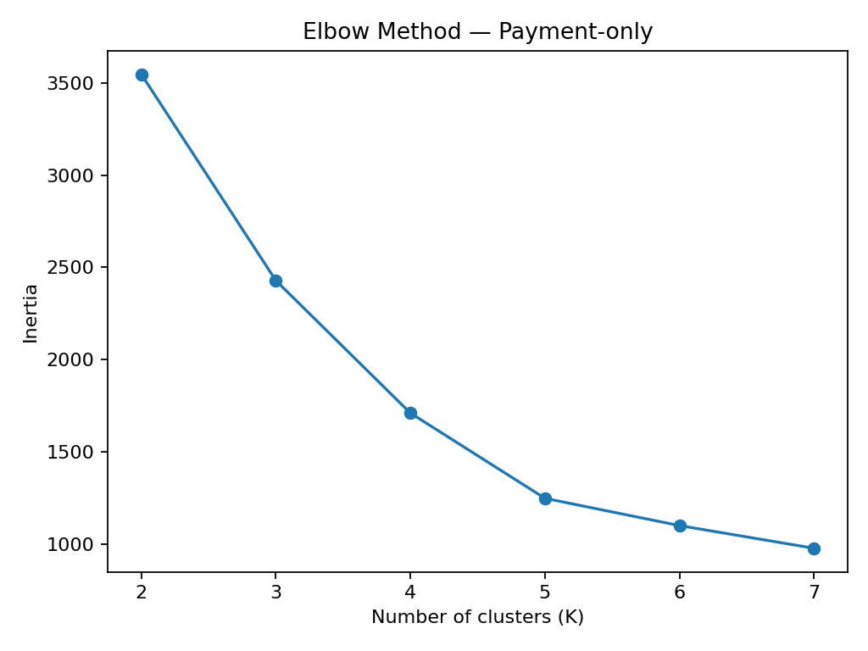
Figure 4. Elbow plot for payment-only features.
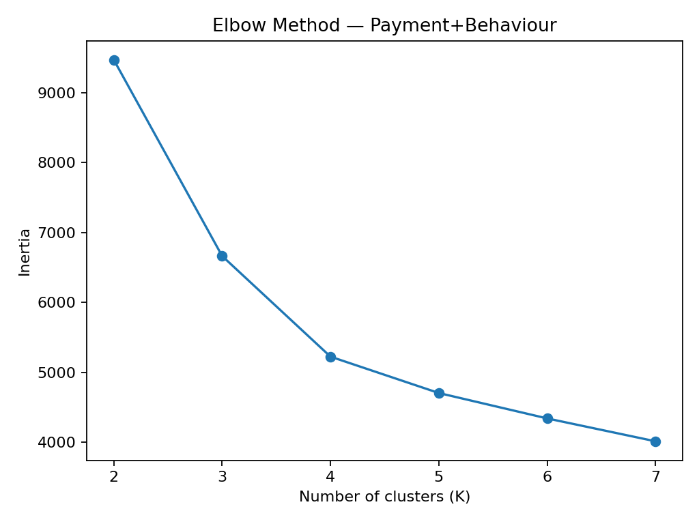
Figure 5. Elbow plot for payment and behavioural features.

Model comparison
Feature set | Model | K | Silhouette | Davies–Bouldin
Payment-only | K-Means | 5 | 0.536 | 0.802
Payment-only | Agglomerative | 5 | 0.475 | 0.794
Payment+Behaviour | K-Means | 4 | 0.442 | 1.017
Payment+Behaviour | Agglomerative | 4 | 0.419 | 1.203

With the corrected payment-mode representation, payment-only K-Means has a Silhouette Score of 0.536, compared with 0.442 for combined features. The payment-only Agglomerative solution has a slightly lower Davies–Bouldin Index (0.794) than payment-only K-Means (0.802). For combined features, K-Means scores 0.442 on silhouette and 1.017 on Davies–Bouldin, outperforming Agglomerative on both metrics. These are internal metrics on synthetic data; business usefulness and validation on real data remain necessary.
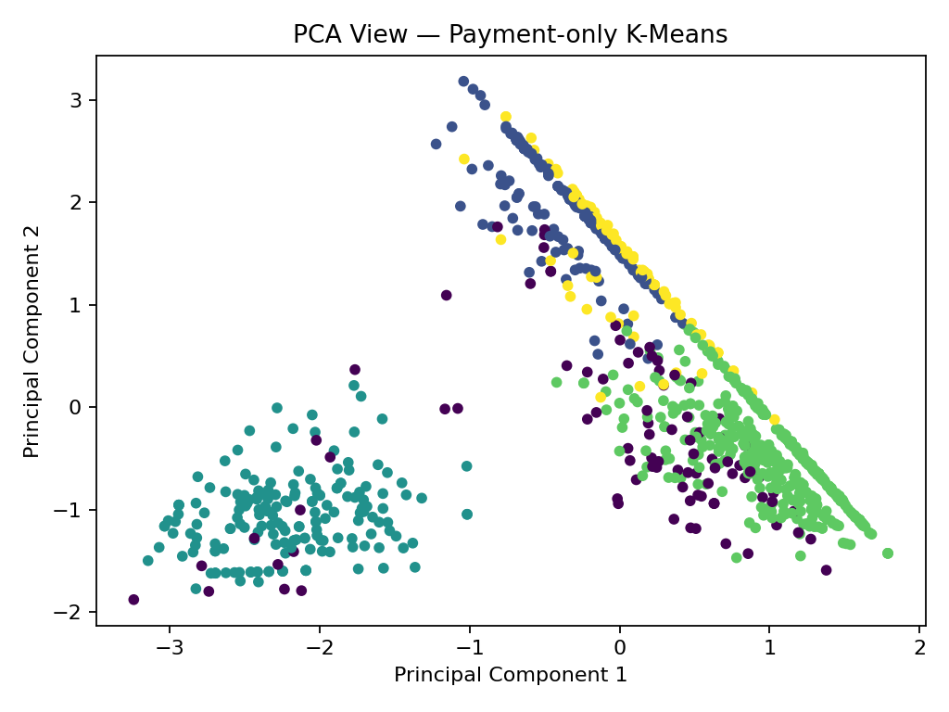
Figure 6. PCA view of payment-only K-Means clusters.
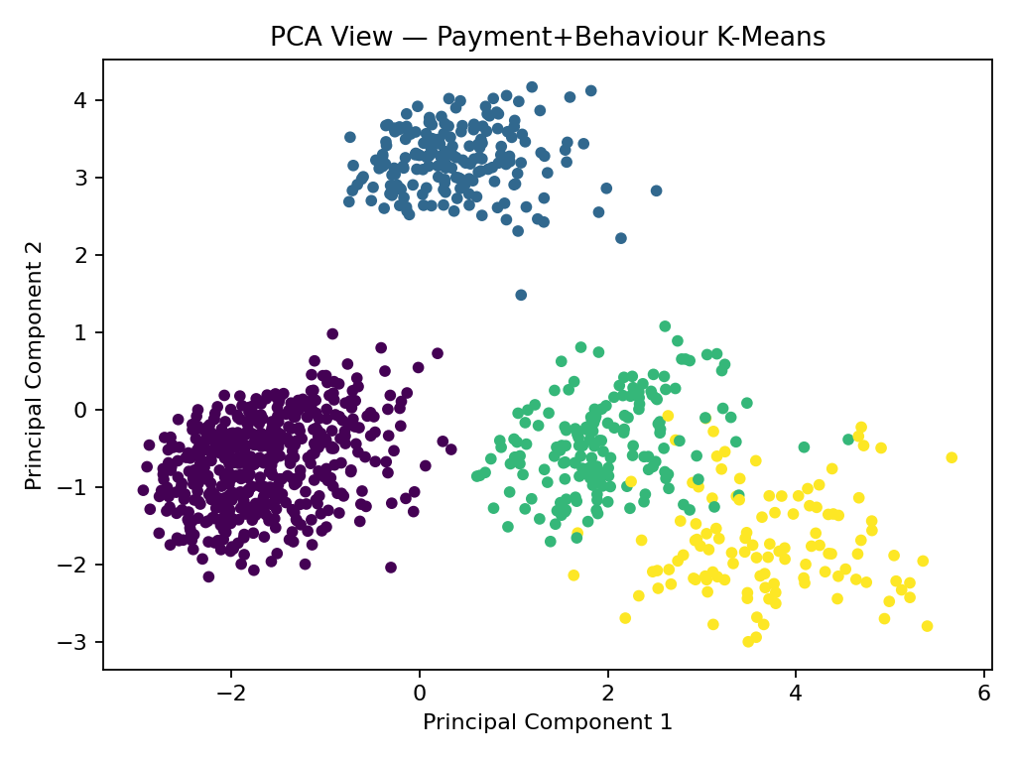
Figure 7. PCA view of combined-feature K-Means clusters.

8. Customer Cluster Profiles
The combined-feature K-Means model produced four clusters in this run. The table below shows average customer characteristics for each cluster. Cluster numbers are assigned by the algorithm and do not have a meaning by themselves; the descriptions are based on the measured averages.
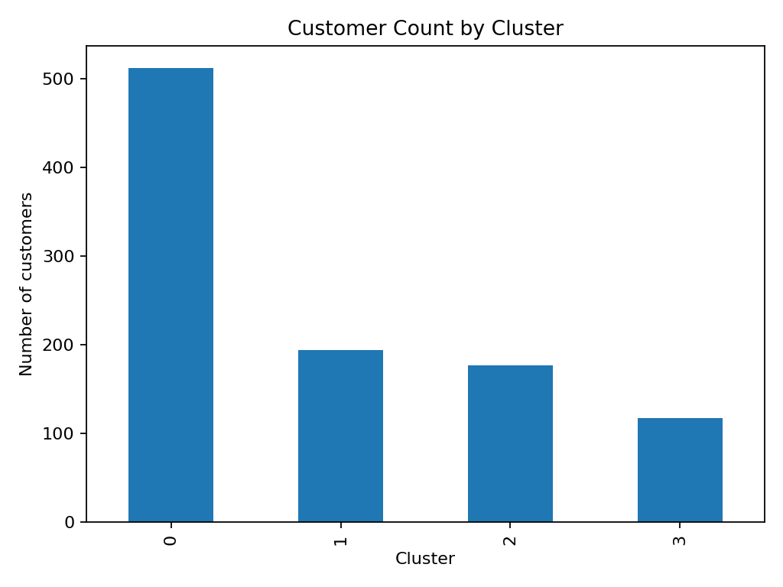
Figure 8. Number of customers in each combined-feature cluster.
Cluster | Customers | Txn count | Avg txn value | Digital ratio | Card ratio | Cash ratio | Cashback rate | EMI rate
0 | 512 | 22.1 | Rs 870 | 73% | 14% | 4% | 70% | 8%
1 | 194 | 16.0 | Rs 492 | 15% | 7% | 71% | 4% | 6%
2 | 177 | 14.3 | Rs 2,798 | 25% | 66% | 1% | 21% | 7%
3 | 117 | 9.6 | Rs 3,573 | 34% | 26% | 1% | 31% | 79%

Cluster 0 - Frequent digital and offer users
This is the largest group (512 customers). It averages about 22 transactions, a 73% digital payment ratio and a 70% cashback usage rate. A suitable business test would be app/UPI benefits with clear limits, measured against a control group.

Cluster 1 - Cash-oriented, lower average transaction value
This group contains 194 customers, with a 71% cash ratio and an average transaction value of about Rs 492. Keep cash as an accessible option and avoid assuming that every customer wants to move to digital payments.

Cluster 2 - Card-oriented, higher average transaction value
This group contains 177 customers, with a 66% card ratio and an average transaction value of about Rs 2,798. Card-linked rewards could be tested where the additional spend covers the incentive cost.

Cluster 3 - EMI-oriented, higher average transaction value
This group contains 117 customers, with a 79% EMI usage rate and an average transaction value of about Rs 3,573. Present instalment terms clearly and avoid promotional designs that encourage unaffordable borrowing.
These labels describe patterns in the synthetic data only. Recalculate them if the dataset changes.
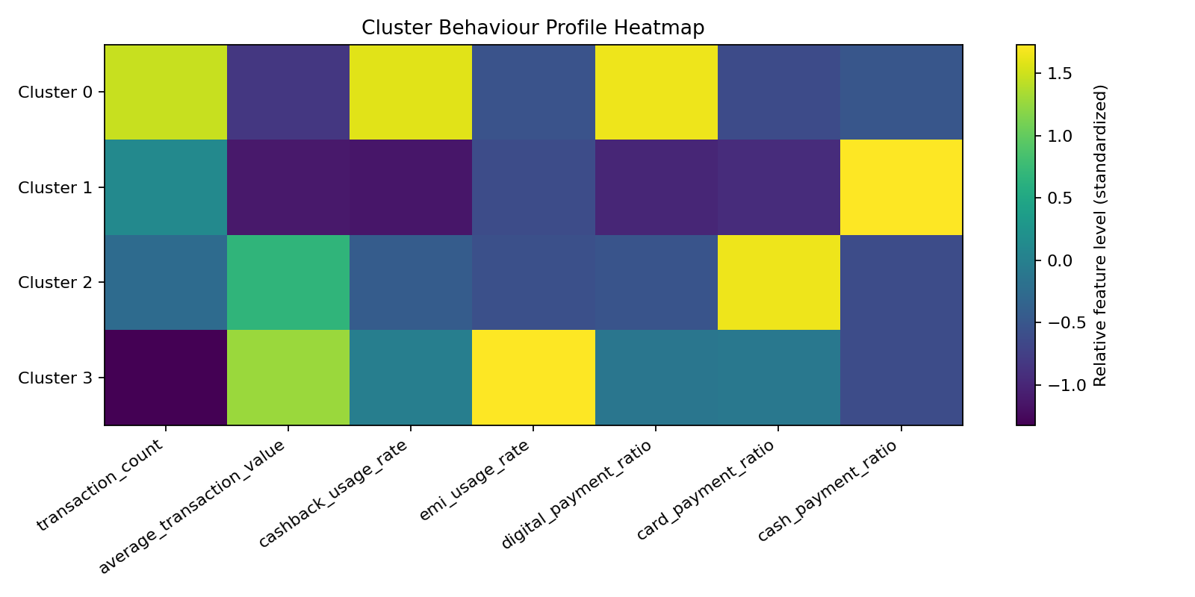
Figure 9. Relative feature levels by cluster.

9. Industry Recommendations
The cluster profiles suggest several tests: offer relevant digital-payment benefits to the digital-heavy group; evaluate card-linked rewards for the card-oriented group; preserve cash checkout options for cash-oriented customers; and present EMI costs and conditions clearly to EMI-oriented customers. Cashback should not be given to every transaction automatically. Promotions should be tested with a control group and judged on incremental outcomes such as conversion, repeat purchases and margin, not only transaction volume.

10. Limitations
The data is synthetic and does not represent an actual retailer, bank or payment provider. The results are exploratory and do not establish that payment behaviour causes spending patterns. Clustering metrics do not guarantee that segments will be commercially useful. A real implementation would require approved data, privacy safeguards, checks for stability over time and validation with business stakeholders.

11. Conclusion
This project demonstrates a complete unsupervised learning workflow, from data inspection and cleaning to feature engineering, scaling, clustering, evaluation, visualization and recommendations. Comparing two feature sets shows that the feature design affects cluster quality and interpretation. For this synthetic dataset, payment-only features produce better internal separation, while the combined feature set supports a richer customer profile. The results should be treated as a demonstration until validated on real data.

12. Methodological Decisions and Supporting Literature

Why no train-test split is used
This project uses unsupervised clustering and has no labelled target variable to predict. A conventional supervised train-test split is not required for the main clustering experiment. Models and internal metrics are computed on the same cleaned customer-level dataset, so these scores describe in-sample cluster structure, not performance on unseen customers. Before deployment, check segment stability across time periods and validate using approved, representative data and business outcomes.
K selection: inertia is inspected with the Elbow Method for K=2 to 7. The code uses the highest Silhouette Score in that range as a reproducible starting point; interpretability and the Elbow plot should also be considered.

Supporting literature
MacQueen described K-means as a method for partitioning multivariate observations. Rousseeuw proposed silhouette width to help interpret and validate cluster solutions. Davies and Bouldin introduced a cluster-separation measure used as an internal evaluation index. These works support the choice of clustering and evaluation methods. The assignment additionally asks for Elbow analysis, hierarchical comparison, PCA visualization, and business interpretation.

References
- Amity School of Engineering and Technology. Assignment, July-Dec 2026: Fundamentals of Machine Learning (MLE2503), Problem Statement 7: Payment Behaviour & Digital Payment Intelligence.
- MacQueen, J. (1967). Some methods for classification and analysis of multivariate observations. Proceedings of the Fifth Berkeley Symposium on Mathematical Statistics and Probability, Vol. 1, pp. 281-297.
- Rousseeuw, P. J. (1987). Silhouettes: A graphical aid to the interpretation and validation of cluster analysis. Journal of Computational and Applied Mathematics, 20, 53-65. https://doi.org/10.1016/0377-0427(87)90125-7
- Davies, D. L., & Bouldin, D. W. (1979). A cluster separation measure. IEEE Transactions on Pattern Analysis and Machine Intelligence, PAMI-1(2), 224-227. https://doi.org/10.1109/TPAMI.1979.4766909
- scikit-learn developers. Documentation for KMeans, AgglomerativeClustering, StandardScaler, PCA, silhouette_score and davies_bouldin_score. https://scikit-learn.org/stable/
- pandas development team. pandas documentation. https://pandas.pydata.org/docs/

